Page URL - https://rootcabs.com/taxi-in-chennai/
Slug Suggestion - https://rootcabs.com/cities/taxi-in-chennai
Primary Keyword
taxi service in chennai
cab services in chennai
Secondary & LSI Keywords
cab booking chennai
cabs in chennai
cab services in chennai
taxi in chennai
best cab service in chennai
taxi booking chennai
cab rental chennai
car booking in chennai
outstation cabs chennai
online cab booking chennai
best taxi service in chennai
call taxi chennai
chennai cab booking
chennai airport taxi
airport taxi chennai
chennai to pondicherry cab
taxi from chennai to pondicherry
outstation car rental chennai
outstation cab booking chennai
online taxi service in chennai
book taxi in chennai
online taxi booking chennai
outstation taxi chennai
airport taxi service chennai
chennai airport cab services
outstation taxi service in chennai

Reference - https://www.redtaxi.co.in/chennai-cab-booking
https://www.uber.com/in/en/r/cities/taxi/chennai-tamil-nadu-in/

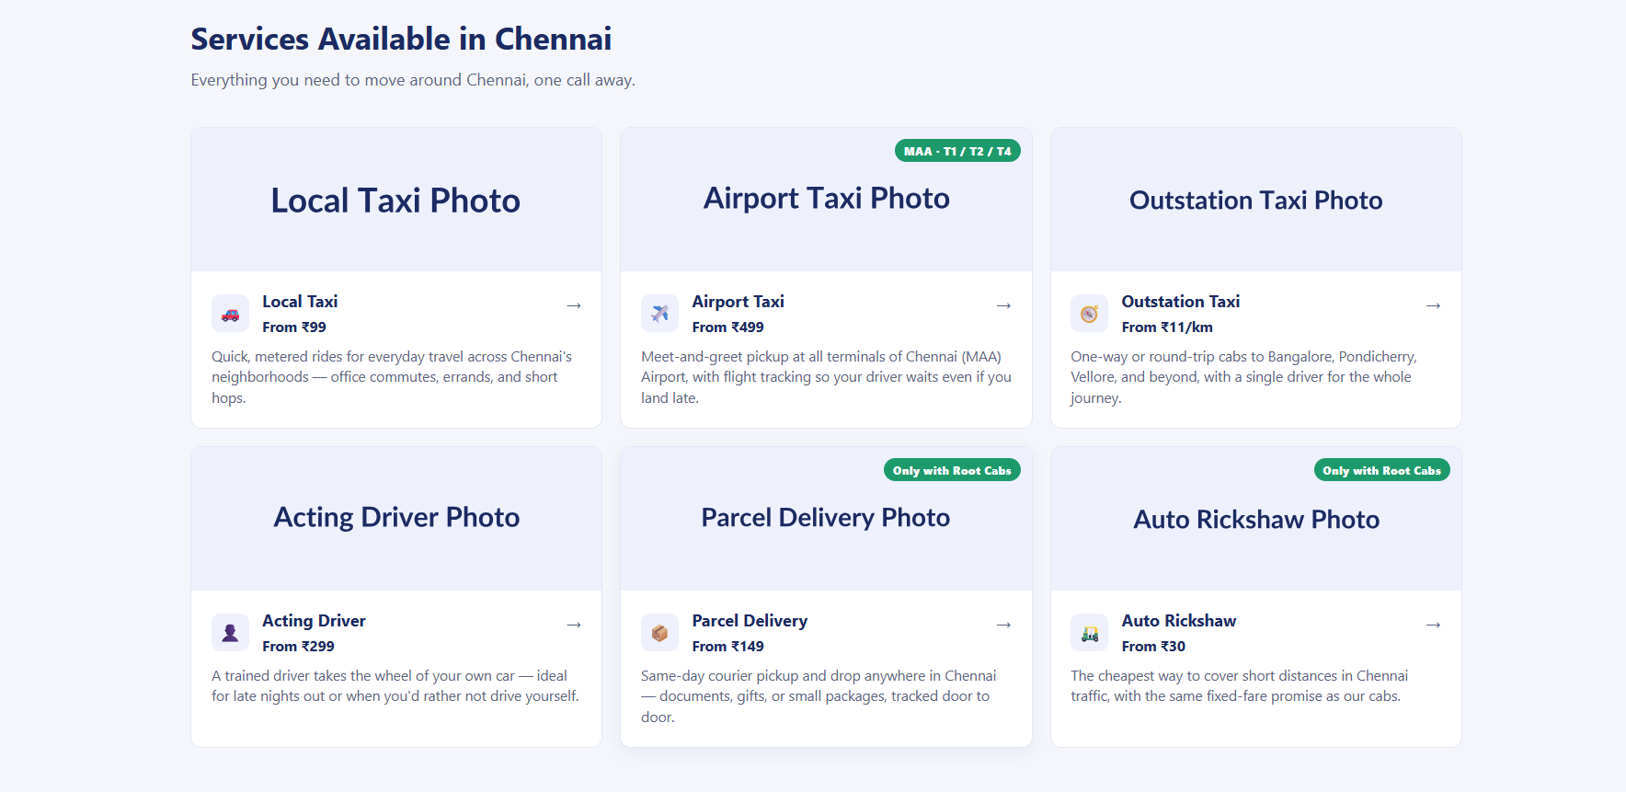

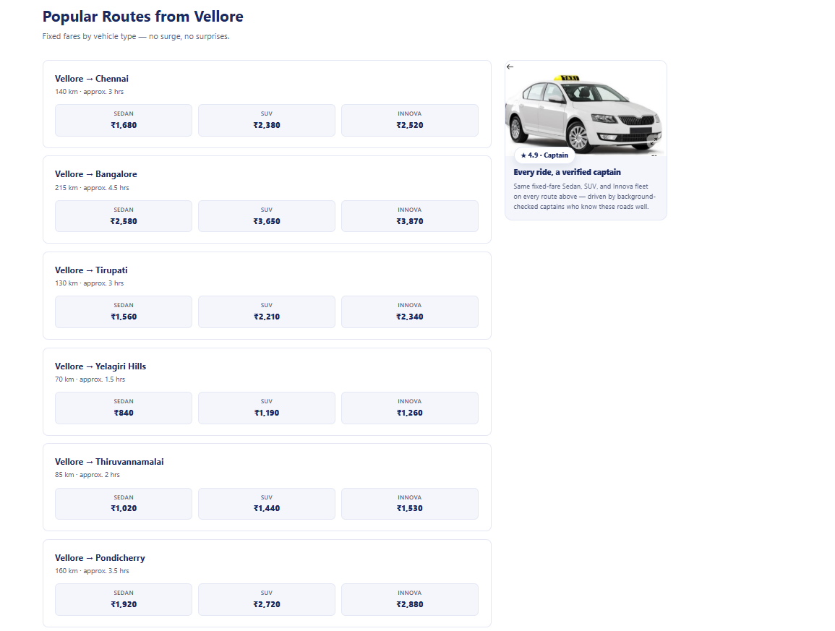

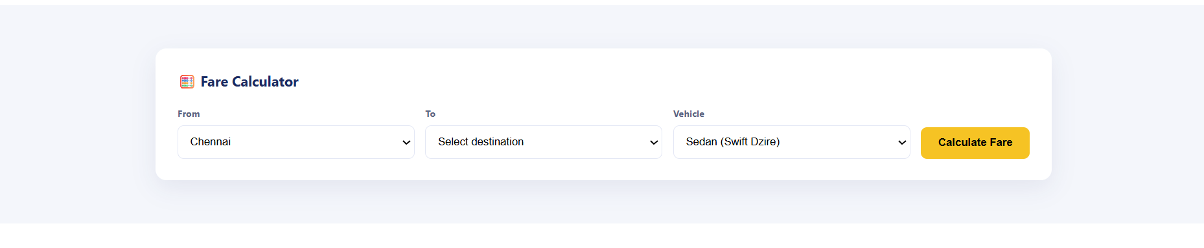

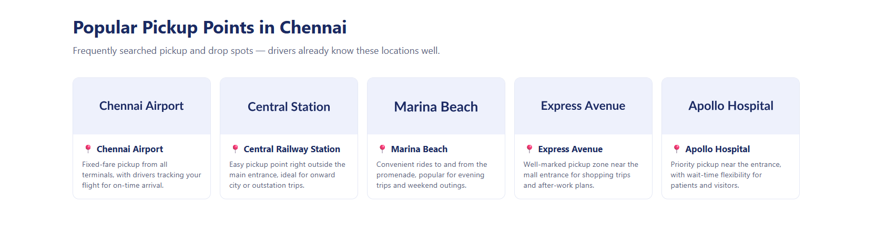

Reference - https://www.redtaxi.co.in/chennai-cab-booking
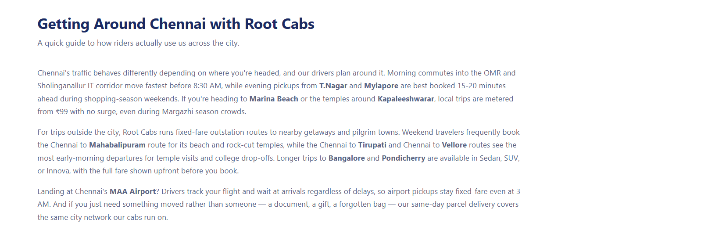
Reference - https://www.redtaxi.co.in/chennai-cab-booking (this leads to the internal linking for outstation and hourly rental - airport transportation.

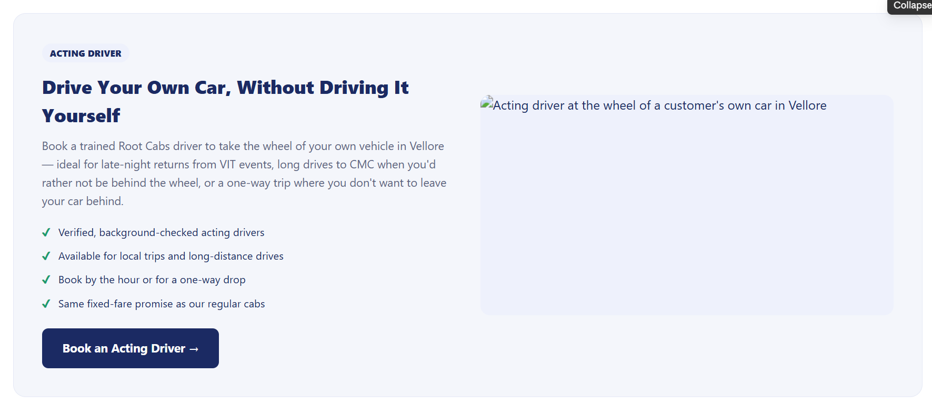

rental cars in chennai with driver
car rental in chennai with driver
chennai self drive cars
one day car rental in chennai with driver
luxury car rental in chennai with driver
driver for hire chennai
car hire in chennai with driver
car driver rental chennai
car on rent in chennai with driver
hire driver in chennai
Get a driver in Chennai
car rental in chennai with driver
one day car rental in chennai with driver
car driver rental chennai
car hire in chennai without driver
rent car in chennai with driver
rental car with driver chennai

What is the rate of acting driver in Chennai?

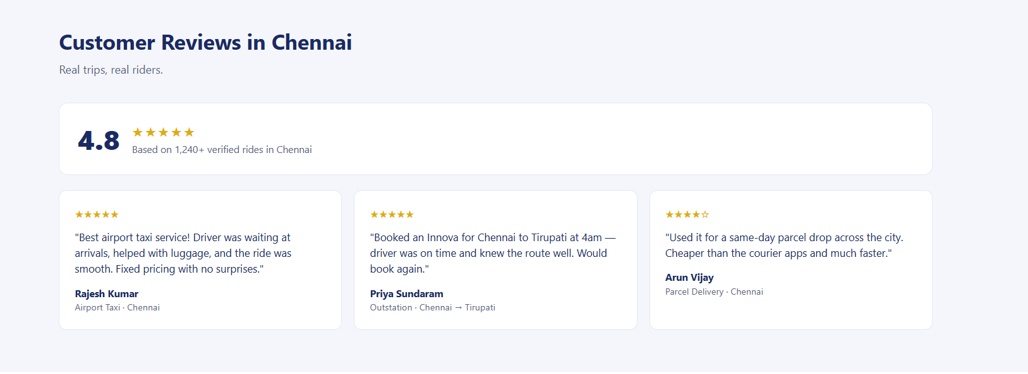

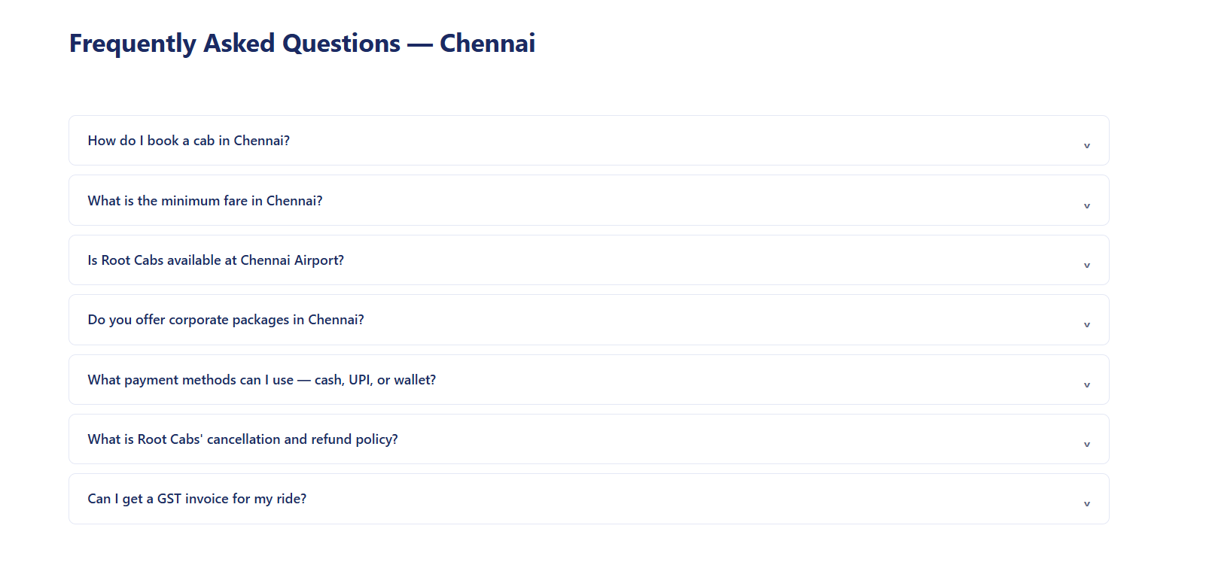

Which is the best cab service in Chennai?
What is the cheapest way to book an outstation cab from Chennai?
What is the best cab service in Chennai for outstation trips?
How much does Root Cabs charge per km in Chennai?
Does the outstation fare include tolls and taxes?
Can I change my drop location or reschedule after booking?
What is Root Cabs' cancellation and refund policy?
What payment modes does Root Cabs accept, and can I get a GST invoice?

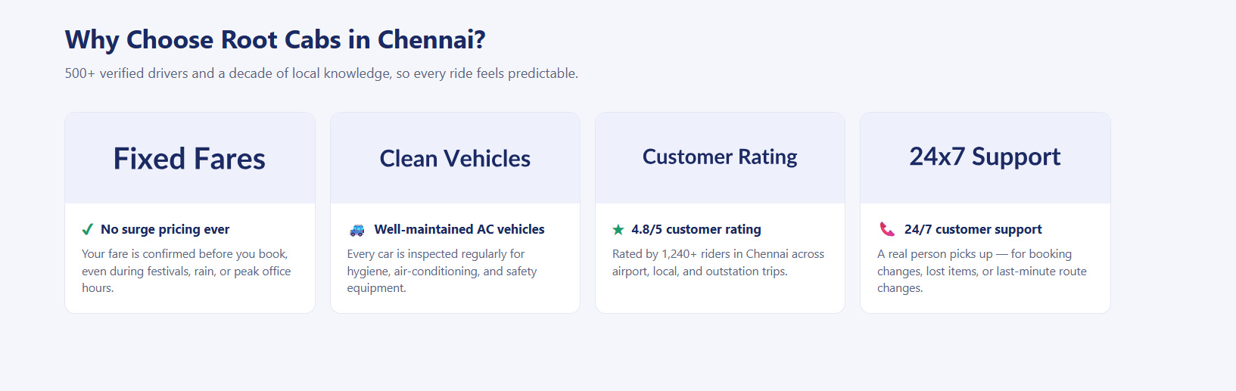

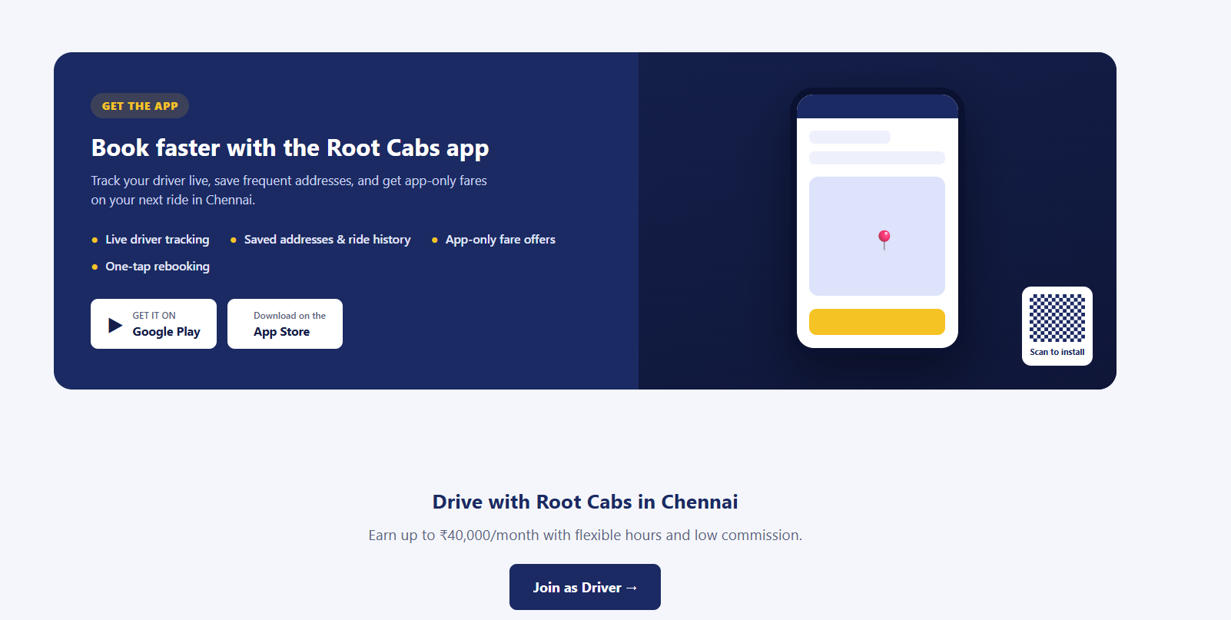

rental cars in chennai with driver
car rental in chennai with driver
chennai self drive cars
one day car rental in chennai with driver
luxury car rental in chennai with driver
driver for hire chennai
car hire in chennai with driver
car driver rental chennai
car on rent in chennai with driver
hire driver in chennai
Get a driver in Chennai
car rental in chennai with driver
one day car rental in chennai with driver
car driver rental chennai
car hire in chennai without driver
rent car in chennai with driver
rental car with driver chennai

What is the rate of acting driver in Chennai?

